LW1 Tutorial: Intro to optimisation and Linear programming
Task 1.
You are given the following data for a linear programming problem where the objective is to maximize the profit from allocating three resources to two nonnegative activities.
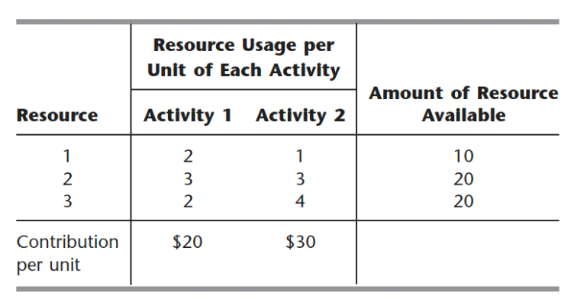
Contribution per unit means profit per unit of the activity.
- What are the input parameters for the problem?
- Formulate a linear programming model for this problem by clearly define the decision variables, objective function and constraints.
- Use the graphical method to solve this model.
- Display the model on an Excel spreadsheet.
- Use the spreadsheet to check the following solutions: (x₁, x₂) = (2, 2), (3, 3), (2, 4), (4, 2), (3, 4), (4, 3). Which of these solutions are feasible? Which of these feasible solutions has the best value of the objective function?
- Use the Excel Solver to solve the model by the simplex method.

Task 2.
Ed Butler is the production manager for the Bilco Corporation, which produces three types of spare parts for automobiles. The manufacture of each part requires processing on each of two machines, with the following processing times (in hours):
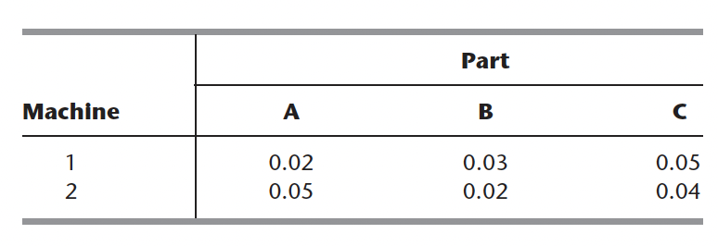
Each machine is available 40 hours per month. Each part manufactured will yield a unit profit as follows:
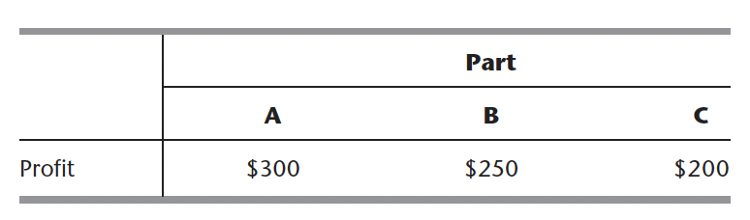
(a) Formulate a linear programming model for this problem.
(b) Display the model on an Excel spreadsheet.
(c) Make three guesses of your own choosing for the optimal solution. Use the spreadsheet to check each one for feasibility and, if feasible, to find the value of the objective function. Which feasible guess has the best objective function value?
(d) Use the Excel Solver to solve the model by the simplex method.

Task 3: Agricultural production regional planning problem
The SOUTHERN CONFEDERATION OF REGION is a group of three regions in Israel. Overall planning for this group is done in its Coordinating Technical Office. This office currently is planning agricultural production for the coming year.
The agricultural output of each region is limited by both the amount of available irrigable land and the quantity of water allocated for irrigation by the Water Commissioner (a national government official). These data are given in the following table.
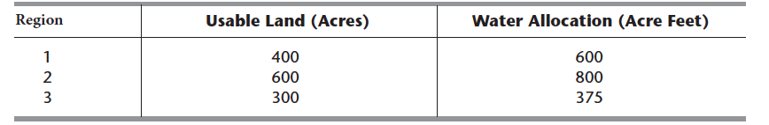
The crops suited for this region include sugar beets, cotton, and corn, and these are the three being considered for the upcoming season. These crops differ primarily in their expected net return per acre and their consumption of water. In addition, the Ministry of Agriculture has set a maximum quota for the total acreage that can be devoted to each of these crops, as shown in the following table.
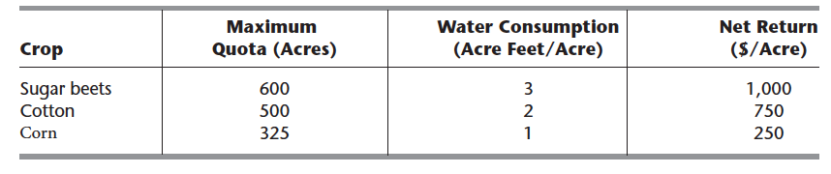
Because of the limited water available for irrigation, the Southern Confederation of Region will not be able to use all its irrigable land for planting crops in the upcoming season. To ensure equity between the three regions, it has been agreed that every region will plant the same proportion of its available irrigable land. For example, if region 1 plants 200 of its available 400 acres, then region 2 must plant 300 of its 600 acres, while region 3 plants 150 acres of its 300 acres. However, any combination of the crops may be grown at any of the region. The job facing the Coordinating Technical Office is to plan how many acres to devote to each crop at the respective region while satisfying the given restrictions. The objective is to maximize the total net return to the Southern Confederation of Region as a whole.
- Step 1: Define the decision variables for the problem
- Step 2: Define the objective function for the problem
- Step 3: Define the following constraints:
  - Useable land for each region:
  - Water allocation for each region:
  - Total acreage for each crop:
  - Equal proportion of land planted:
  - Nonnegativity:
- Step 4: Solve the model in Excel
Optional Task: Work through LW1_LP.ipynb provided in Google Colab which is an implementation of LP models.

